Erikson Consumer Announces Partnership with MAGIC CHEF® Appliance to Distribute Iconic Housewares Across Canada

FOR IMMEDIATE RELEASE
Media contact:
Nataliya Potapova
nataliya.potapova@eriksonconsumer.com
Tel: + 1 438 801 3818

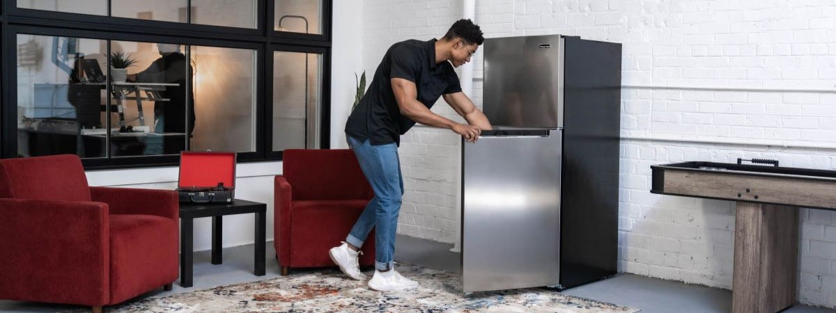

BAIE D’URFÉ, QC, June 6th, 2024 – Erikson Consumer is thrilled to announce an exciting new partnership with MAGIC CHEF® Appliance to distribute the renowned MAGIC CHEF® brand of housewares across Canada.

MAGIC CHEF®, celebrating its 95th anniversary this year, has been a household staple known for its reliability, innovation, and value. Erikson Consumer is proud to bring this iconic brand to Canadian homes, starting with an array of refrigerators and microwave appliances. These products will be available to Canadian consumers starting this fall, just in time for the holiday season. Consumers can look forward to enhancing their kitchens with dependable and stylish appliances that have been household favorites for decades.

“This partnership with MAGIC CHEF® Appliance marks a significant milestone for Erikson Consumer,” said Allison Chow, Director of Home Comfort at Erikson Consumer. “We are thrilled to expand our portfolio with such a trusted brand. This collaboration aligns perfectly with our commitment to providing high-quality products to our customers. We look forward to the exciting opportunities this partnership will bring and to contributing to the growth of the MAGIC CHEF® brand in Canada.”

"We are excited to partner with Erikson Consumer," says David Graham – VP Sales and Marketing. "Their reputation as leaders in the distribution of consumer goods perfectly aligns with our renowned brand of high-quality appliances. Together, we will significantly expedite our expansion across Canada."

For more information about the upcoming MAGIC CHEF® product launch or to learn more about Erikson Consumer, please visit our website at Erikson Consumer.

About Erikson Consumer:
Erikson Consumer (an Exertis | JAM business) is one of Canada’s largest independent distributors of audio and electronic solutions, with a portfolio fortified by the industry’s most renowned brands of mobile, multimedia, and home audio/video products.

About MAGIC CHEF® Appliance:
For 95 years, MAGIC CHEF® has been a household name that at-home chefs turn to for dependable, easy-to-use kitchen appliances. Today, MAGIC CHEF® continues that time-honored tradition, offering a versatile line of kitchen essentials to help busy consumers create magical moments and simplify their lives. MAGIC CHEF® is a Registered trademark of CNA International, Inc. dba MC Appliance Corporation. All Rights Reserved.

