Erikson Consumer Announces Partnership with Victrola

FOR IMMEDIATE RELEASE
Media contact:
Nataliya Potapova
nataliya.potapova@eriksonconsumer.com
Tel: + 1 438 801 3818

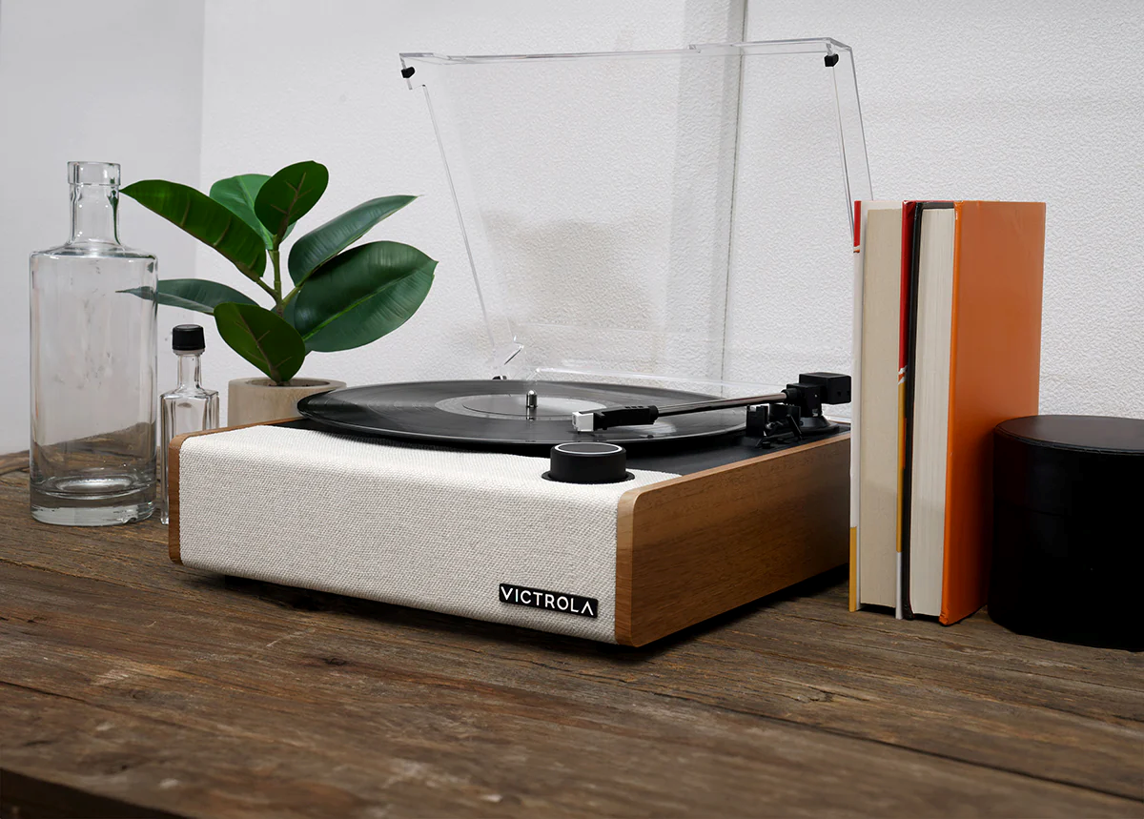
Victrola Eastwood II Hybrid Record Player with VINYLSTREAM Technology

FOR IMMEDIATE RELEASE

Victrola Announces Strategic Partnership with Leading Canadian Distributor

BAIE D’URFÉ, QC, May 28, 2024 – Erikson Consumer is excited to announce a new strategic partnership with Victrola, the world-renowned producer of high-quality turntables and audio equipment. This collaboration mints Victrola's commitment to providing music enthusiasts with access to the brand’s acclaimed turntables and audio solutions.

Victrola's partnership with Erikson Consumer marks a major milestone in its global expansion strategy, making it easier than ever for Canadian consumers to find a wider range of Victrola products in more stores. Erikson Consumer, with its extensive network and commitment to customer satisfaction, is the ideal partner to facilitate this market growth.

“We are thrilled to partner with Erikson Consumer to bring Victrola’s unique blend of timeless aesthetics and modern technology to Canadian consumers,” said Victrola CEO Scott Hagen. “This partnership is a significant step in our growth strategy, and we are confident that Erikson Consumer’s expertise and market reach will help us connect with new customers who share our passion for music.”

Erikson Consumer will offer an extensive range of Victrola’s products, ranging from their ever-popular hybrid record players to their award-winning premium turntables. This partnership not only enhances product availability in major retail locations across Canada but also provides robust support and services for Canadian customers.

“We are excited to collaborate with Victrola and add their esteemed products to our portfolio,” said Jocelyn Rowcliffe, Director of Multimedia category of Erikson Consumer. “Victrola’s dedication to quality and innovation resonates with our own values, and we are eager to introduce their products to our network of retailers and consumers.”

About Victrola:
Victrola has been a leading manufacturer of audio products since 1906, beginning with the first in-home record player in the U.S. Since then, Victrola has grown into a global brand with a mission of bringing lifelong music memories to everyone. Victrola continues to deliver innovative turntables and audio solutions designed with simplicity, beauty, and superior sound, providing an immersive experience for music lovers everywhere.

About Erikson Consumer:
Erikson Consumer (an Exertis | JAM business) is one of Canada’s largest independent distributors of audio and electronic solutions, with a portfolio fortified by the industry’s most renowned brands of mobile, multimedia, and home audio/video products.

