Erikson Consumer Partners with RENPHO as Exclusive Canadian Distributor, Expanding Home Comfort Offerings with Smart Health Innovations

FOR IMMEDIATE RELEASE
Media contact:
Nataliya Potapova
Nataliya.potapova@eriksonconsumer.com
Tel: +1 438 801 3818

November 22nd 2024, BAIE D’URFÉ – Erikson Consumer is thrilled to announce an exclusive distribution partnership with RENPHO, a global leader in smart health and wellness products. As the newest addition to Erikson Consumer’s Home Comfort category, RENPHO will bring its ecosystem of advanced health and wellness solutions to the Canadian market, empowering retailers and consumers alike to enhance their lifestyle with smart, accessible products.

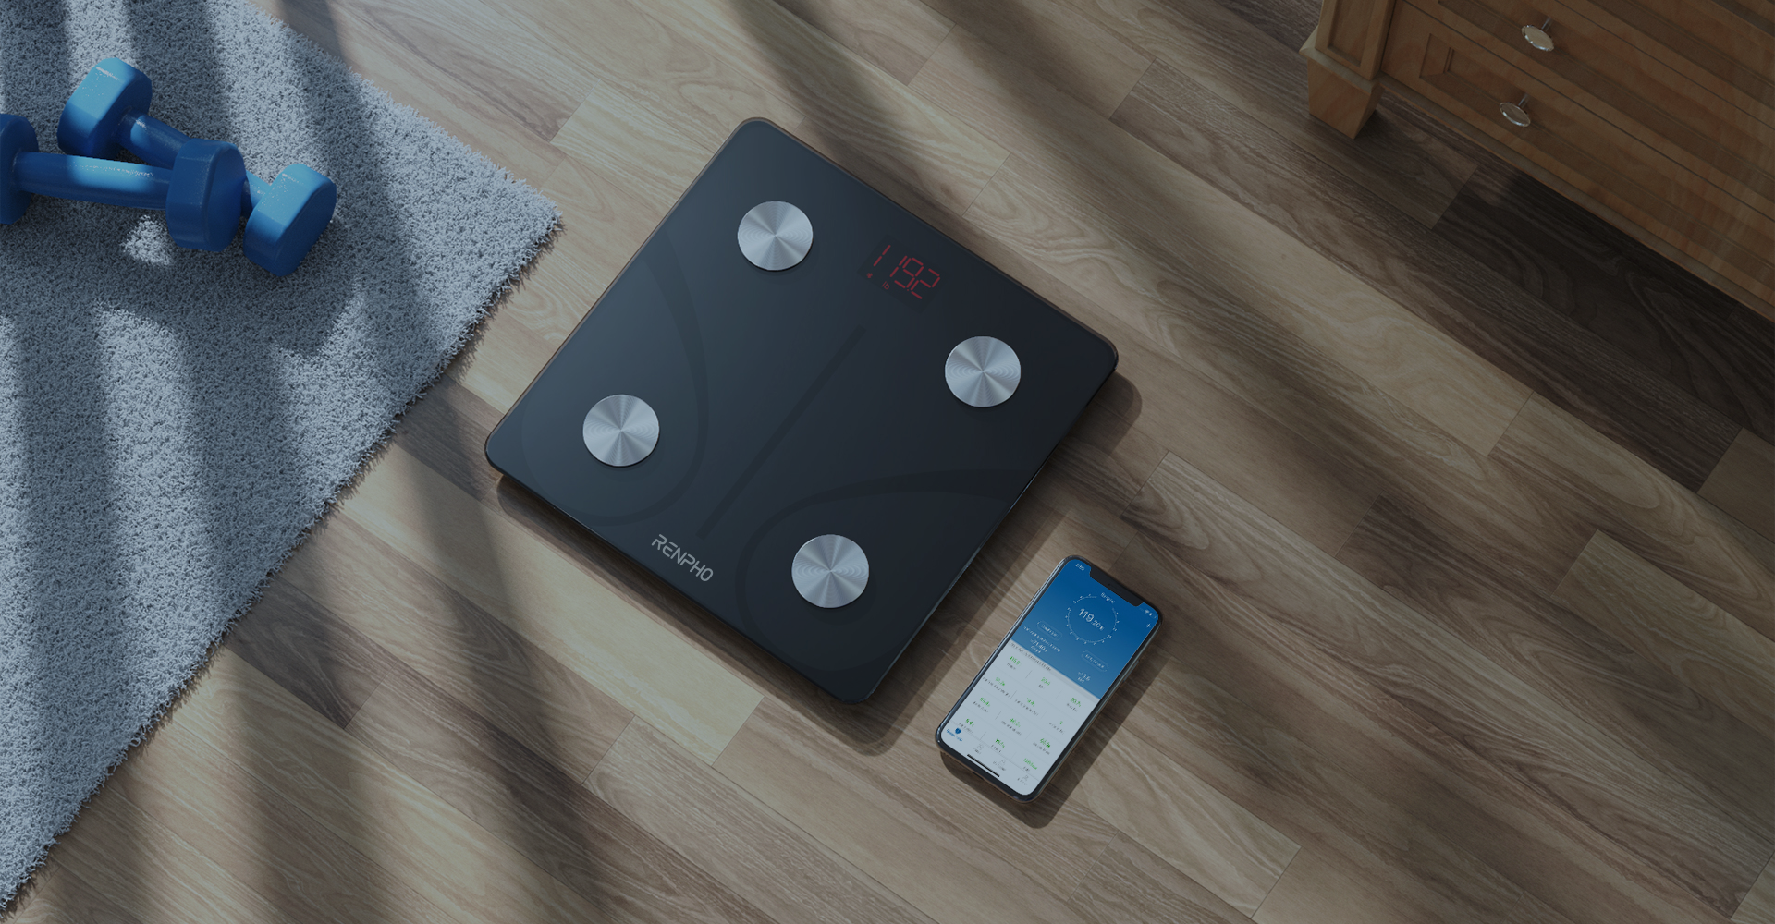

A Vision for Smart, Accessible Health
Since its founding in 2016, RENPHO has been on a mission to make healthy living easier and more affordable. Known for its commitment to innovation, RENPHO has developed a unique ecosystem of smart products designed to support a healthier lifestyle, from daily activity tracking to targeted massage solutions. With a flagship product lineup that includes the #1 eye massager worldwide and one of the most trusted smart scale brands globally, RENPHO has earned a reputation for quality and reliability among millions of users.

RENPHO’s products are designed to work seamlessly with the RENPHO app, which integrates with Apple Health, Google Fit, Fitbit, Samsung Health, and MyFitnessPal. This compatibility allows users to sync data across devices and track wellness goals with ease. The RENPHO app acts as a “passport” to personal health insights, giving users real-time feedback and empowering them to make informed decisions about their health journey.

A Diverse and Innovative Product Line
RENPHO’s range of products makes it easy for users to integrate wellness into their daily routines. With options that cater to diverse wellness needs, Canadian retailers can now pre-order the following RENPHO products through Erikson Consumer:

- Body Scales ($34.99 - $99.99 MAP): These smart scales offer precise measurements and detailed body composition data to help users stay informed about their fitness journey.
- Health Monitoring Devices ($39.99 - $54.99 MAP): RENPHO’s smart tape measures and nutrition scales make it simple for users to track and manage key health metrics.
- Eye Massagers ($99.99 - $169.99 MAP): RENPHO’s eye massagers, known for their soothing and rejuvenating effects, offer relaxation and relief from eye strain.
- Foot Massagers ($179.99 - $599.99 MAP): These advanced foot massagers provide deep tissue relief, enhancing overall wellness and comfort.
- Body Massagers ($74.99 MAP) and Massage Guns ($99.99 - $199.99 MAP): RENPHO’s body massagers and massage guns are powerful, portable solutions for muscle relief and recovery.

These products, now available for pre-order, represent a significant addition to Erikson Consumer’s Home Comfort category, enhancing retailers' offerings with high-quality, in-demand wellness solutions. Canadian retailers can contact their Erikson Consumer sales representative for pre-order opportunities and detailed product information.

A Commitment to Health and Innovation
As part of their mission to make “Smart Healthy Living” accessible, RENPHO develops all products with user experience at the forefront, incorporating feedback from users and insights from wellness experts. This user-centered approach has allowed RENPHO to build a community of over 20 million customers globally who trust RENPHO products to support their wellness goals.

About RENPHO
RENPHO is a global leader in smart health and wellness products, committed to empowering individuals worldwide to improve their health and wellness through accessible, data-driven solutions. With a wide-ranging product lineup, from smart body scales to innovative massage devices, RENPHO creates products that seamlessly integrate with its proprietary app, allowing users to track and understand key health metrics. Established in 2016 in California, USA, trusted by over 11 million customers worldwide, RENPHO remains dedicated to its mission of making smart healthy living accessible to all.

About Erikson Consumer
Erikson Consumer, an Exertis | JAM business, is one of Canada’s largest independent distributors of audio & electronic solutions with a portfolio fortified by the industry’s most renowned brands of multimedia, luxury audio, home comfort and mobile audio products. Its product selection includes award-winning brands that can be found in all key national and regional chains, furniture/appliance and specialized independents. Erikson Consumer takes pride in offering clients product training from introductory to technical levels, supported by dedicated sales and marketing teams prepared to assist before and after sales, with stock readily available from a state-of-the-art 250,000 square foot warehouse facility.
With over fifty years of experience, Erikson Consumer has grown and diversified, providing the Canadian marketplace with a resourceful, reliable, and innovative distribution network.

