**JBL Reimagines the Home Theater Experience**

FOR IMMEDIATE RELEASE

Media contact:

Nataliya Potapova

[Nataliya.potapova@eriksonconsumer.com](mailto:Nataliya.potapova@eriksonconsumer.com)

Tel: +1 438 801 3818

**The JBL Modern Audio AV Receivers and Stage 2 Loudspeakers are High-Performance Audio Products Designed for the Next Generation of Music and Movie Enthusiasts: Stylish, Intuitive, Scalable, and Attainable**

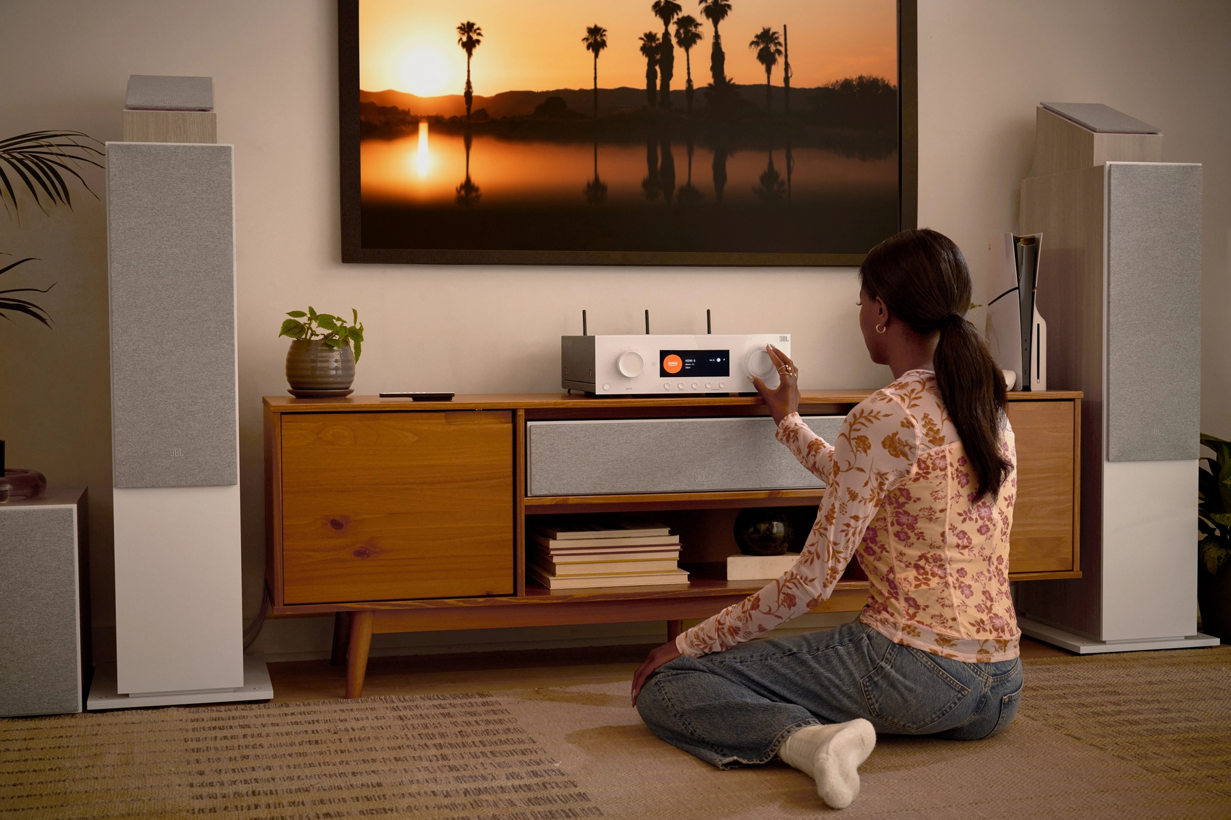

**July 17th, Baie-D'urfé** – JBL announced today the JBL Modern Audio (MA) AV Receivers and Stage 2 Loudspeakers – high-performance home theater solutions for the next generation of music and movie enthusiasts.

JBL MA AV Receivers and Stage 2 Loudspeakers are crafted to blend seamlessly into modern home interiors, and refreshingly simple to install, connect, and upgrade. They offer consumers a unified and cohesive system that combines simplicity, design, quality, and scalability – all at an affordable price.

Designed and engineered to function together, they provide the perfect out-of-the-box solution for all types of home entertainment enthusiasts, from those looking to level up their existing system to those who aspire to experience high-performance component immersive audio.

Harnessing JBL’s rich expertise in cinema sound, including digital amplification and patented loudspeaker technology, these imaginative products take the complexities out of the home cinema experience.

**A Home Theater Solution Without the Complexity**

Many consumers find the home theater component purchasing experience intimidating and overly complex. Not so with JBL MA AV Receivers and Stage 2 Loudspeakers as they were purposefully designed as a simple, turnkey system, both easy to understand and simple to install. Buying a single branded solution engineered to operate in unity effectively removes the need to figure out which components to combine, giving users the peace of mind that comes from knowing that everything they need is provided. Setup and upgrades are equally simple, so users can spend less time installing their system and more time enjoying it.

**Redefining Simplicity**

Featuring intuitive functionality, ease of use, and seamless integration, the JBL MA AV Receivers and Stage 2 Loudspeakers have simplicity at their core. Using the EZ Set EQ mobile app, users can perfectly calibrate the system to match their space in minutes, while the Wi-Fi-enabled AVRs feature “Works with SmartThings” integration, allowing users to create automated routines that control their other IOT devices with just one simple button press. The system is compatible with a wide variety of audio platforms. Whether they want to connect their music from their mobile phone via Apple AirPlay or Chromecast, Bluetooth pairing, or streaming from Spotify, users can count on a smooth and seamless audio experience.

**Design That Stands Out**

The JBL MA AV Receivers and Stage 2 Loudspeakers match today’s lifestyle, both in the way they function and the way they look. Slim and sleek, with a contemporary, playful design, the entire range fits perfectly with modern interiors thanks to our two-color options of Latte and Espresso.

**JBL: The Gold Standard in Sound**

With more than 75 years of experience, JBL is the go-to audio provider for movie theaters, recording studios and luxury home theaters around the globe and whose engineers have won coveted Academy Awards, including two in 2002 for groundbreaking technical innovations. Developed at the JBL Center of Acoustics Excellence in Northridge, California, the systems’ advanced acoustics – featuring next-generation patented HDI waveguides for room-filling sound and anodized tweeters for crystal-clear highs – were designed by the same engineers who create the most advanced high-performance audio systems on the market today.

**Scalable to User’s Needs**

Whether users are just starting out with a basic two-channel system, upgrading from a soundbar or simple home audio system, or looking to build a high-end home theater setup featuring 8K HDMI video, Dolby Atmos® immersive sound and DTS:X, this product range can be scaled accordingly. Moreover, the performance of each model has been optimized both individually and as a system, giving users the freedom to create the setup they want without ever having to sacrifice on sound quality.

“JBL is recognized as the leader in high-performance cinematic experiences, so it should come as no surprise that our new line of home cinema products punches above its weight class,” said Dave Tovissi, Vice President & General Manager, Luxury Audio at HARMAN International. “Solving for modern consumer behaviors and concerns was front and center when we developed these products. We designed the systems to blend perfectly into today’s lifestyle, giving users the sound quality, and simplicity of use they always wanted from a home theater system but never found – until now.”

**Meet the JBL Home Theater Line-Up**

The JBL MA AV Receivers are available in a variety of models, including:

The 60W JBL MA310 5.2-channel 4K AV Receiver – MAP $599.99 CAD

The 75W JBL MA510 5.2-channel 8K AV Receiver – MAP $849.99 CAD

The 110W / 125W MA710 / MA7100HP 7.2-channel 8K (High Performance) AV Receiver – MAP $1,199.99 - $1,799.99 CAD

The 140W JBL MA9100HP, with either 5.2, 7.2, or 9.2 channels, Dolby Audio® and DTS® or Dolby Atmos and DTS:X support, low noise Class D amplification, and broad compatibility – MAP $2,399.99 CAD

JBL Stage 2 Loudspeakers also offer a wide array of models and options, including:

The 260F Floor-standing models – MAP $699.99 CAD (ea.) / $1,399.99 CAD (pr)

The 280F Floor-standing models – MAP $849.99 CAD (ea.) / $1,699.99 CAD (pr)

The 240B Bookshelf models with separate floor stands – MAP $429.99 CAD (pr)

The 250B Bookshelf models with separate floor stands – MAP $569.99 CAD (pr)

The 245C Center Channel speaker – MAP $569.99 CAD (ea.)

The 240H Dolby Atmos enabled Height Module – MAP $429.99 CAD (pr)

The 200P Subwoofer – MAP $699.99 CAD (ea.)

The 220P Subwoofer – MAP $849.99 CAD (ea.)

The JBL MA Series AV Receivers and JBL Stage 2 Series Loudspeakers will be available starting from July 2024 exclusively distributed in Canada by Erikson Consumer. Contact your sales representative for more information.

**About Brand**

For over 75 years, JBL has shaped life’s most memorable moments at the intersection of music, lifestyle, gaming and sports. JBL elevates listening experiences with superior audio quality and product designs that encourage individuality and self-expression. With unmatched professional credentials and industry-leading innovation, JBL is a trailblazer in the audio industry because of passionate and talented engineers and designers around the globe. JBL Pro Sound is the foremost technology pushing culture forward through major pop culture events and partnerships with the world’s top talent across music, sports and esports.

**About Erikson Consumer**

Erikson Consumer, an Exertis | JAM business, is one of Canada’s largest independent distributors of audio & electronic solutions with a portfolio fortified by the industry’s most renowned brands of multimedia, luxury audio, home comfort and mobile audio products. Its product selection includes award-winning brands that can be found in all key national and regional chains, furniture/appliance and specialized independents. Erikson Consumer takes pride in offering clients product training from introductory to technical levels, supported by dedicated sales and marketing teams prepared to assist before and after sales, with stock readily available from a state-of-the-art 250,000 square foot warehouse facility.

With over fifty years of experience, Erikson Consumer has grown and diversified, providing the Canadian marketplace with a resourceful, reliable, and innovative distribution network.