**Cyrus Announces the 40 Series – A New Beginning for the Brand**

FOR IMMEDIATE RELEASE

Media contact:

Nataliya Potapova

[Nataliya.potapova@eriksonconsumer.com](mailto:Nataliya.potapova@eriksonconsumer.com)

Tel: +1 438 801 3818

**BAIE D’URFÉ, QC, October 9th 2024**–

Cyrus Audio, the much-loved and renowned British audio brand has announced the arrival of the 40 Series, a new beginning in the story of Cyrus Audio. Focused around four core models, the 40 series provides the listener with a streamlined premium audio experience that will fit seamlessly into the home of today’s music lovers while offering an exceptional audio performance. Engineered from anodized aluminum and with all key components custom designed, the 40 series is proud to be made in Britain, the home of Cyrus.

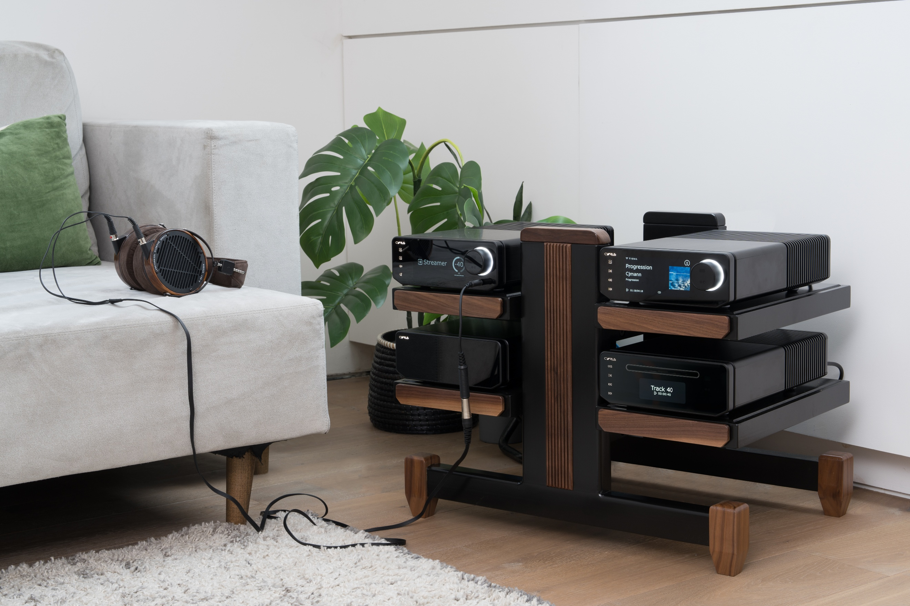

The first thing you’ll notice about the 40 series, and it is impossible to miss, is the all-new sleek design, and what a good job they have made of it. The front panel is uncluttered, with a headphone connection and a beautiful edge to edge glass finish that hides a high-resolution TFT display, bringing full colour album art to all you streaming fans out there.

It is good to see that the attention to detail did not stop there, with the main chassis being made from aluminum, and finished in an eye catching anodized brushed black. The volume control has been given the level of attention not normally seen, having been custom designed from five separate elements and also engineered from solid aluminum, providing very positive feedback to the user.

Cyrus have also designed a brand-new remote control for the 40 series, which perfectly matches the finish and fits perfectly into your hand for easy control from the comfort of your sofa. If you prefer your hi-fi to blend into the background, they have also covered that with the ability to auto turn-off the display which then comes to life when you approach the unit. You also won’t see the normal amount of visible screw heads across the 40 Series, in fact the only place you will see any on show is the rear panel, with the main body being held together via the very cleverly designed feet.

The changes aren’t only on the outside, with the 40 Series being treated to a brand-new DAC design from Cyrus. Based upon the latest offering from ESS, the Sabre ES9039Q2M chipset and HyperStream IV Dual DAC technology has been analyzed by their engineering team and the board layout fully optimized to tune the DAC so that the 40 series can achieve the highest possible performance.

When we were discussing the new 40 Series with Chris Hutcheson, Head of Marketing at Cyrus, Chris wanted to make it very clear that this is not an anniversary range of products. “Yes, we are celebrating our 40th anniversary this year, but the 40 Series demonstrates a new beginning at Cyrus under the leadership of Nick Clarke. This is just the beginning of some very exciting plans at Cyrus.”

We are very happy to see that Cyrus has retained the half width design that is so synonymous with the brand, but by adding a centimeter here and there, the products definitely stand out on the shelf stronger than previous products. The team at Cyrus have been working on the 40 series for the past 2 years, which began with a 360° review of their sales trends over the past 10 years. Chris explained “we are a small but very talented team here at Cyrus. We need to make sure that we have a clear and focused direction, so that we are designing and launching products that are in demand from our customers.”

Hopefully that explains why the 40 series is made up of an integrated amplifier, integrated cd player, network streamer and external power supply. The team are also working on a brand-new phono preamplifier, which we have been told will be available later next year. The very exciting news is that the 40 Series is only ‘part one’ of Cyrus’ new beginning product roadmap. We cannot wait to see what else is on its way from the team at Cyrus in 2025.

**Quote**

Nick Clarke said.

“It fills me with immense pride to be part of the Cyrus story, one that now spans over 40 years of audio excellence. The core brand values of providing value for money with great sound quality achieved with good, solid engineering have never been so important to the team here. We continue to engineer and build in the UK as it allows us the best control over the entire process of bringing these products to the end customer. I sincerely hope that when you listen to any Cyrus product, you appreciate the skill, dedication and hard work that has gone into each one and it helps connect you to the music that you love.”

**40 Series – Product Details**

*40 AMP – Integrated Amplifier*

Whether you are a digital or analogue fan, the 40 AMP was designed to be at the center of your home audio and provide the perfect partner regardless of your preferred playback source. Delivering the level of exceptional performance expected from today’s music fans, this integrated amplifier has the capabilities to drive even the most demanding of loudspeakers. With 100 watts per channel into 6 ohms, and a generously over-specified power supply the 40 AMP is capable of reproducing the scale and drama of the musical performance in your own home.

Encased in the sleek design of the 40 series aluminum casing with a 5” hi-resolution full colour TFT display, the 40 AMP has been designed to fit into today’s modern lifestyle. Sitting at the center of this multi-functional amplifier is an electronic circuit that has been designed entirely by the R&D team at Cyrus. The DAC is based upon the latest chipset from ESS, the ES9039Q2M, and has been reworked to provide an audio signal that replicates the artists original recording to a level not seen in a Cyrus product before.

As well as multiple digital and analogue connections, the 40 AMP has a low noise MM phono stage which inherits many of its design features from the award-winning Classic PHONO. The phono stage performs at a level way above its class, featuring low background noise and high dynamic range, providing the perfect complement for a quality vinyl turntable.

The features of the 40 AMP do not stop with your love of music, now with the addition of the latest HDMI eARC input, your home audio now provides the opportunity to enjoy your favorite films or TV series through your chosen loudspeakers, putting the 40 AMP well and truly at the center of your home entertainment.

*40 ST – Streaming Music Player*

If your music is digital, then the 40 ST, Cyrus’ highest performing network streamer is the product for you. Powered by the user-friendly and popular BluOS hi-res streaming platform and presented in the sleek design of the 40 series aluminum chassis, you will experience your favorite music at up to 24-bit/192kHz at lightning-fast speeds across your home network with minimal lag and zero loss in sound quality.

The 40 ST is packaged with the new Cyrus remote but is ultimately controlled with the intuitive BluOS app, available for iOS, Android, Kindle, Mac or PC computers. Providing direct access to over 20 natively integrated streaming services, thousands of radio stations from around the world, and even your own music library on a network drive. The 40 ST also supports Roon, Airplay 2 and allows for MQA decoding.

With their best performing DAC, based on the ESS ES9039Q2M on board, the 40 ST not only provides uncompromising sound quality, coupled with the convenience and ease of use of the BluOS streaming platform. The 40 ST becomes far more than just a streamer, allowing you to connect any digital device via the coaxial and optical inputs, so that the performance of the 40 ST stretches far beyond just music.

*40 CD – Integrated CD Player*

Cyrus is well known for designing award winning cd players, so it comes as no surprise that they have included one in this new range. Ten years ago, they developed what they call ‘servo evolution’ which is centered around the philosophy of extracting the data on the disc as accurately as possible the first time to create an almost silent noise-floor.

So, with such a rich history of high performing cd players to choose from, Cyrus could easily have relied on a previous model for the 40 CD. Lucky for us, they have done just the opposite. Taking the brand-new 40 series DAC, Cyrus have continued to push the boundaries in what is possible with digital to analogue conversion, and they have also redesigned the 40 CD power supply to minimize interaction between the complex mix of signals which includes fast digital audio, sensitive analogue audio, high current servo and system controls.

By completely segmenting these circuits the digital control circuits run from a dedicated, high-efficiency supply, whilst other parts of the player are powered from an over-specified universal power supply. Nine individual stage regulators smooth and distribute power within the player according to demand, which Cyrus boasts has taken CD playback to another level. We cannot wait to hear these improvements for ourselves.

*40 PSU – External Power Supply*

Cyrus have been designing external power supplies since the launch of the PSX back in the 80s, and the 40 PSU continues that strong tradition with what can only be described as a very intelligent little black box! Incorporating its own on-board micro-processor, the 40 PSU can be attached to all products available in the 40 series, communicating directly to consistently provide the best configuration of power from a full range of voltage output levels.

Providing multiple supplies, all the output voltages from the 40 PSU are digitally controlled internally, so are extremely stable and virtually noise free. Something else that is very good news for owners of current Cyrus products is that the 40 PSU and PSU-XR can be used across both ranges, so that has got to be something to smile about.

The 40 series will be exclusively distributed in Canada by Erikson Consumer, at the below prices. To find out more, contact your sales rep directly.

Cyrus 40 AMP: $7500 CAD

Cyrus 40 ST: $5500 CAD

Cyrus 40 CD: $5500 CAD

Cyrus 40 PSU: $4700 CAD

**About Cyrus**

**Cyrus Audio is a world-renowned British manufacturer of high-performance audio systems, known for delivering precision engineering and exceptional sound quality. With a legacy of over three decades, Cyrus continues to push the boundaries of hi-fi innovation, creating products that blend cutting-edge technology with timeless design. Each component is meticulously crafted in the UK, ensuring a superior audio experience for music lovers around the globe. Cyrus is committed to bringing listeners closer to the music with unparalleled clarity and emotional impact.**

**About Erikson Consumer**

Erikson Consumer, an Exertis | JAM business, is one of Canada’s largest independent distributors of audio & electronic solutions with a portfolio fortified by the industry’s most renowned brands of multimedia, luxury audio, home comfort and mobile audio products. Its product selection includes award-winning brands that can be found in all key national and regional chains, furniture/appliance and specialized independents. Erikson Consumer takes pride in offering clients product training from introductory to technical levels, supported by dedicated sales and marketing teams prepared to assist before and after sales, with stock readily available from a state-of-the-art 250,000 square foot warehouse facility.

With over fifty years of experience, Erikson Consumer has grown and diversified, providing the Canadian marketplace with a resourceful, reliable, and innovative distribution network.